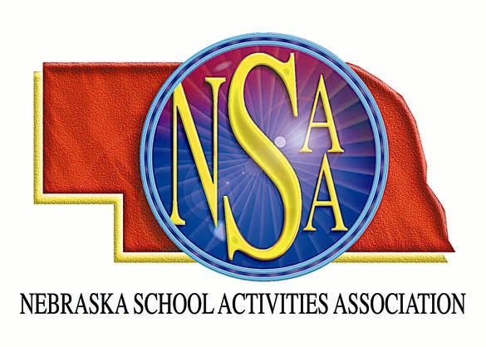

Anselmo-Merna needs a football crew for September 28, 2007. Please contact Deb Bargstadt, Activities Director, Anselmo-Merna HS, 308 643-2224, or dbargsta@esu10.org.

